PROTECTION AND PERMANENCY M EMORANDUM, 13-16

TO: Service Region Administrators
Service Region Administrator Associates
Service Region Clinical Associates
Regional Program Specialists
Family Services Office Supervisors

FROM: Tina Webb, Assistant Director
Division of Protection and Permanency

DATE: November 22, 2013

SUBJECT: Exiting a Child from Foster Care to a Relative’s Custody

The purpose of this memorandum is to clarify the process of exiting a child from DCBS custody, to the custody of a relative. When this occurs, the Exit Resource screen should be completed in TWIST, as shown:

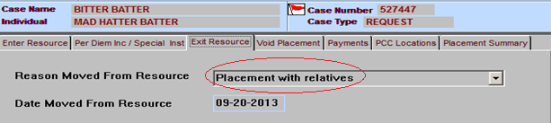
- Reason Moved from Resource: Click the drop down arrow and choose “Placement with relatives.”
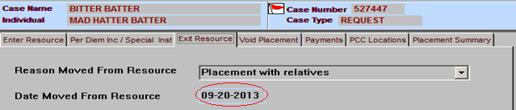
- Date Moved from Resource: Enter the date in which the child was moved from foster care and placed with the relative.
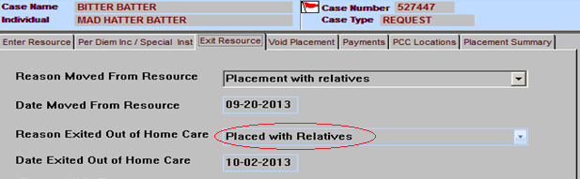
- Reason Exited Out of Home Care: Click the drop down arrow and choose “Placed with Relatives.”
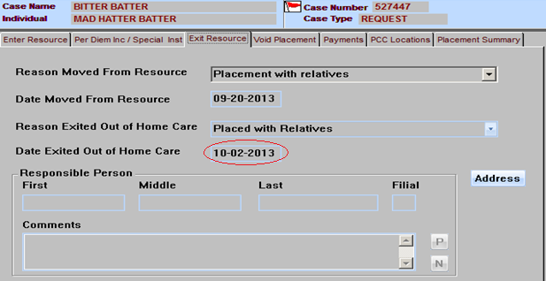
- Date Exited Out of Home Care: Enter the date that custody of the child was transferred to the relative.
- Responsible Person: Enter the relative’s name in the “First,” “Middle” and “Last” name fields; and enter the relative’s address and telephone number in the “Comments” box.
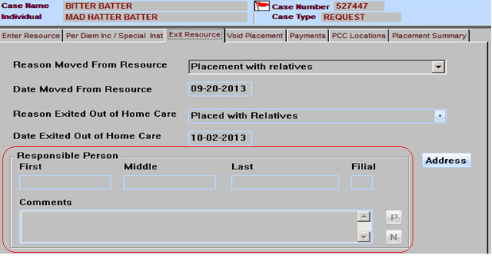

If you have any questions regarding this memorandum, please contact via e-mail, Gretchen.marshall@ky.gov, or by telephone at (502) 564-7635, ext. 3587.

